**Assessment**



**I111-Web Fundamentals**

**Assessment Two (Assignment)**

|  |  |  |
| --- | --- | --- |
| **Due Date**  Sunday the 11th of November | **Faculty**  Humanities and Business | |
| **Due Time**  11:55 PM | **School**  Business and ICT | |
| **Weighting**  35% | **Programme**  Bachelor of Information and Communications Technology (Applied) | |
| **Submission Method**  Upload a zipped copy of your entire Website to Moodle | **Learning Outcomes Assessed**   * Create an elementary web site from design documentation | |
| **Conditions**  This is an individual assessment. All work must be your own. |  | |
| **Lecturer**  Richard Dargie | | **Moderator**  Sandra Cleland |

# Key Requirements

***The following are the main requirements for the assessment:***

* This is an individual assignment. You must consult with the lecturer for any clarifications regarding the assignment.
* You will be expected to research some of this assignment to solve parts of the requirements.
* Create the Website using only HTML/CSS/ vanilla JavaScript and the resources supplied   
  (**No Frameworks allowed**).
* Your Website needs only to match the requirements when viewed in a Chrome browser using a Lab Desktop monitor, at 100% zoom level.
* **Do not use inline CSS styles**. Except for the **Open Street Map** <iframe> which comes with it embedded. The **Open Street Map** link is <https://www.openstreetmap.org/#map=2/-41.2/-6.6>
* Ensure the page content matches closely as possible the screenshots provided.
* **Use only CSS Grid** for your layout (no other frameworks).
* You must **NOT use the CSS height, max-height or the HTML height attribute** (this includes using JavaScript to apply the height) on any element except for the <iframe> and Modal.   
  **You can** instead use ***padding*, *margins***or ***line-height*** for enlarging the height to achieve the expected results.
* Hyperlinks do not go anywhere when clicked.
* You must only use a code editor like VS Code/Notepad++ or equivalent. No drag and drop IDE or similar tool is allowed. **Failure to comply with this will mean a failed assessment.**
* Download and extract **assignment-resources.zip** from Moodle to assist you in the website creation. The files consist of the following:
  1. **Images** to be used where indicated in the design specifications provided below.
  2. A text file called **content.txt** to be used as heading text, paragraph text and link text for the assignment. **It must be used as is and not modified**.
* Place your **full name in the <title> element** of the index page.

Full Page View

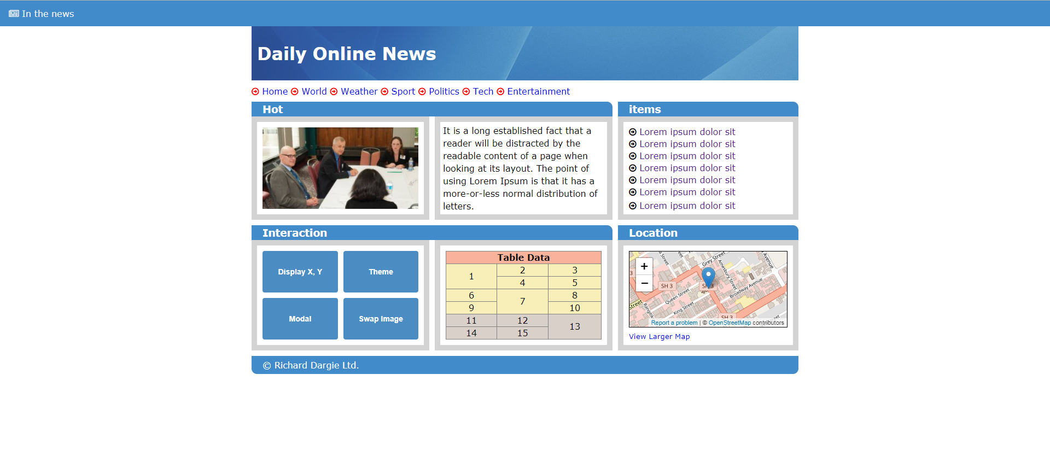

1000px wide

Figure 1 - Web Page viewed with 100% zoom, using Chrome (Lab Desktop)

**Key Specifications**

* Width of main container = 1000px
* Centered on page
* Font family = Verdana
* Font-size = 16px (default)
* Panel headers headings *= <h4>*

**Top Navigation bar**



Figure 2 – Top Nav bar

**Key Specifications**

* background colour = *#428bca*
* text colour = *#ffffff*
* text = <a> and centred vertically in frame and padded away from the left edge by 10px
* font-awesome icon = *far fa-newspaper*
* covers entire screen (0px margins)
* closely matches screenshot

**Main Header**



Figure 3-Main Banner

**Key Specifications**

* background image = *background.jpg*
* text colour = *#ffffff*
* text = <h1> and centred vertically in header frame, padded away from the left edge by 10px
* closely matches screenshot

**Navigation Link Section**



Figure 4

**Key Specifications**

* font-awesome icons = *far fa-arrow-circle-o-right*
* text = <a> and centred vertically in header frame
* no underlines for the links
* first arrow aligns with left edge of container
* space separating icons and text
* closely matches screenshot

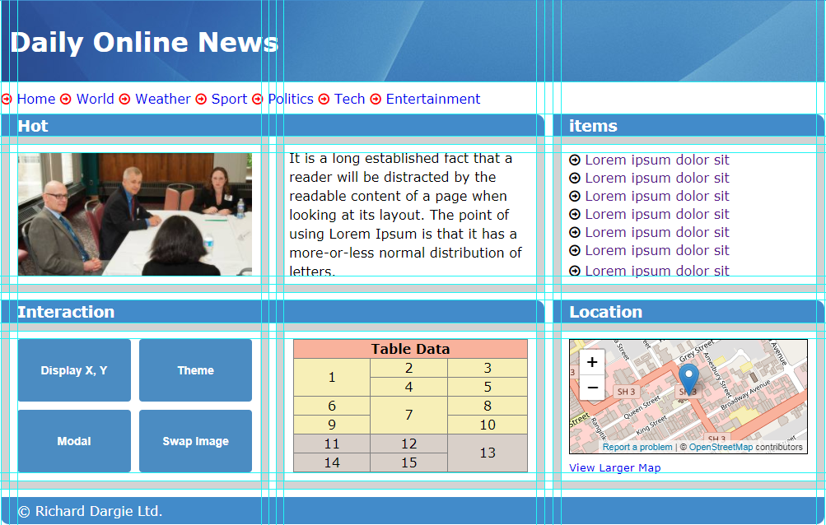

Figure 5-Container showing contents and grid spacing when page has first loaded

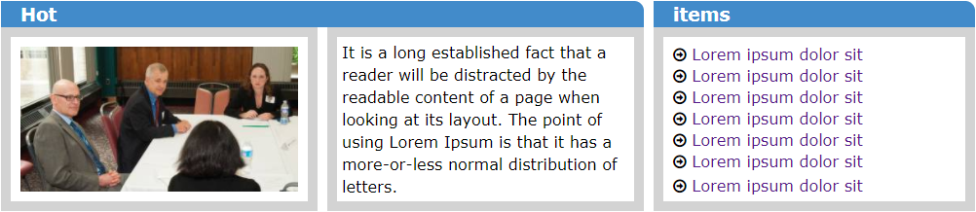

Figure 6-Top section 10+

**Key Specifications**

***Hot Panel***

* *Hot* panel contains a header sitting above two sections (image and text).
* The tops and bottoms of *image* and *paragraph* text line up horizontally (as shown in Figure 6).

***Hot Panel Image section***

* Image on page load = *business.jpg, width = 100%* and fits into the frame showing consistent 10px outer gap.
* Borders = *lightgrey, width=10px.*
* Grid gaps consistently = *10px* (as shown in Figure 6).

***Hot Panel Text section***

* Borders = *lightgrey, width=10px.*
* Grid gaps consistently = *10px* (as shown in Figure 6).
* The *paragraph* text must be exactly as the one provided in the *resources* folder.
* Text has padding from the left edge.

***Items Panel***

* *Items* panel contains a header matching other headings.
* The tops and bottoms of the *hyperlink* text and *paragraph* text (*Hot* section) line up horizontally (as shown above).
* Font-awesome icons = *fa-arrow-circle-o-right, color = #000000,* has 10px padding from the left edge.

Borders *= lightgrey, width=10px.*

* Grid gaps consistently *= 10px* (as shown in Figure 6).
* The *hyperlink* text must be exactly the text provided in the resources folder.

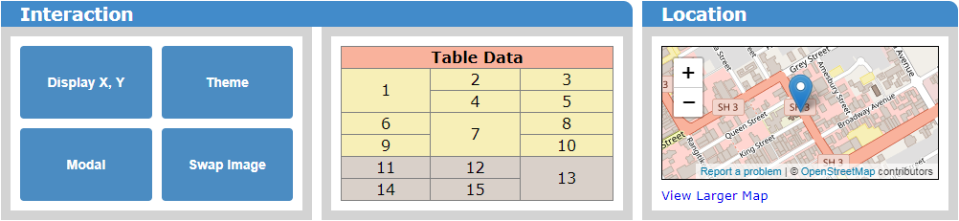

Figure 7-Bottom section

**Key Specifications**

***Interaction Panel***

* *Interaction* panel contains a header sitting above two sections (*buttons* and *table*).
* The tops of the upper buttons and *table* top (*Interaction* section) line up horizontally (as shown in Figure 7).
* The bottom of lower *buttons* and the *table* bottom (*Interaction* section) line up horizontally (as shown in Figure 7).

***Interaction Button section***

* Grid gaps consistently = *10px* (as shown in Figure 7)
* Borders = *lightgrey*, width*=10px.*
* Text centered.

***Interaction Table section***

* grid gaps consistently = *10px* (as shown above)
* *Table* head section colour = *#F9B29C*
* *Table* body section colour = *#F7EFB7*
* *Table* footer section colour = *#D9D0C9*
* *Table* cells show the *data* and *cell* *spacing* as per the screenshot provided.
* Borders = *lightgrey*, width*=10px.*

***Location Panel***

* *Map* is created from *Open Street Maps*, shows UCOL location with marker as shown in screen shot (*research this yourselves*).
* Grid gaps consistently = *10px* (as shown above).
* Borders = *lightgrey*, width*=10px.*
* Bottom of “**View Larger Map**” *hyperlink* text and *table* bottom (*Interaction* section) line up horizontally (as shown in Figure 7)

Footer



**Key Specifications**

* Background colour = *#428bca*
* Text colour = *#ffffff*
* Text padded away from the left edge by 10px
* Closely matches screenshot
* Shows your name and copyright symbol

**JavaScript Interactivity**

1. When the “**Display X, Y**” button is hovered over, the Table should disappear and in its place the *x/y* co-ordinates of the mouse pointers position should display and update as the mouse is moved around the button surface area:

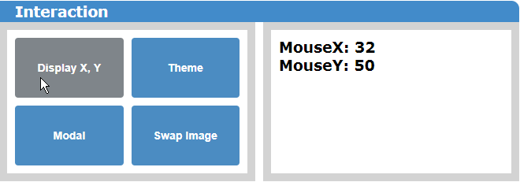

1. When the *mouse* moves off the *Button* the *Table* should re-appear and the coordinates disappear.
2. When the *Theme* button is clicked the panel headers and the top navigation bar should display a green background colour (***#11C034)***

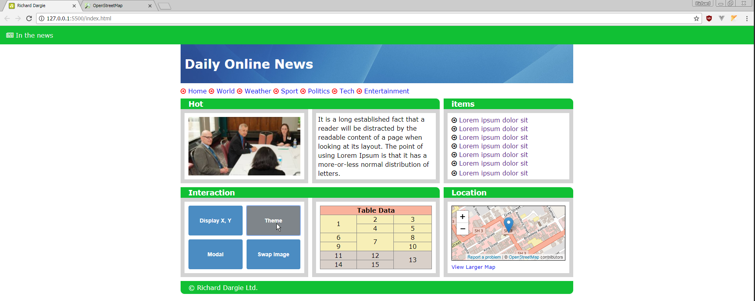

1. When the *Theme* button is clicked again (toggled), the panel headers and the top navigation bar should display the default background colour (***#4b8cc2)***
2. When the *Modal* button is clicked, an image contained in div should appear (modal) as shown below**:**

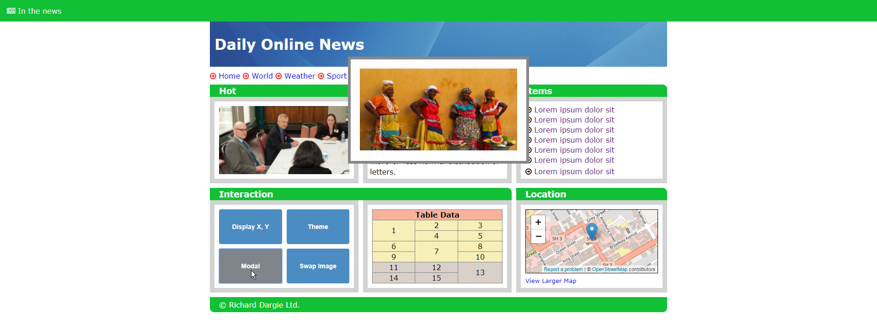

1. When the *Modal* button is clicked again (toggled), the Modal image should disappear.
2. When the *Swap Image*  button is clicked, the default image should change and display another image (this can be found in the resources folder)

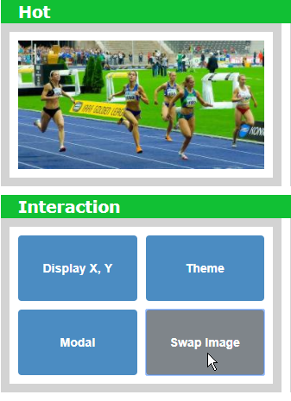

1. When the *Swap Image* button is clicked again (toggled), the default image should reappear

The following Marking Guide will be used to assess (Lecturers discretion) your Assignment.

A+ Maximum

* Meets all requirements.

A+ (85/100)

* Has a minor flaw/error, from only one of the following requirements: *layout, alignment, spacing, and padding*.

1. To A.

* Has no more than two minor flaws/errors, from only one of the following requirements: *layout, alignment, spacing, padding and content.*
* And has three or more *JavaScript* requirements working.

1. To B

* Has no more than three flaws/errors, from any the following requirements: *layout, alignment, spacing, padding and content.*
* And has two or more *JavaScript* requirements working.
* *Note that* more than *one* flaw/error could be from the same requirement in the list.

C To C+

* Has no more than four flaws/errors, from any the following requirements: *layout, alignment, spacing, padding and content.*
* And has one or more *JavaScript* requirements working.
* *Note that* more than *one* flaw/error could be from the same requirement in the list.

D

* Has more than four flaws/errors, from any the following requirements: *layout, alignment, spacing, padding and content*, but made a reasonable attempt (Lecturers discretion)
* Has made a reasonable attempt at *JavaScript* (Lecturers discretion)
* *Note that* more than *one* flaw/error could be from the same requirement in the list.

E

* Has more than four flaws/errors, from any the following requirements: *layout, alignment, spacing, padding and content*, but made a poor attempt (Lecturers discretion)
* Has made a poor attempt at *JavaScript* (Lecturers discretion)
* *Note that* more than *one* flaw/error could be from the same requirement in the list.